**CREATE AND CONFIGURE IBM CLOUD SERVICES**

### *Create The IBM Watson IoT Platform and A Device*

|  |  |
| --- | --- |
| **Date** | 05 November 2022 |
| **Team ID** | PNT2022TMID27179 |
| **Project Name** | Smart farmer -IOT enabled smart farming application |

### 

### 

*To C Create the IBM Watson IoT Platform and A Device*

***IBM CLOUD LOGIN***

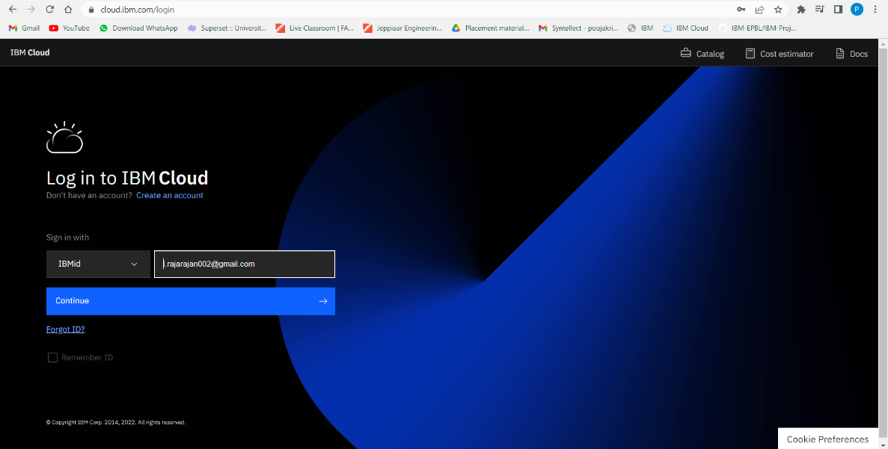

***IBM IOT PLATFORM***

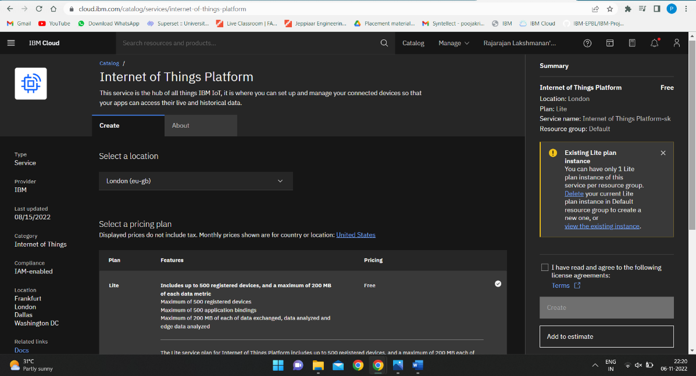

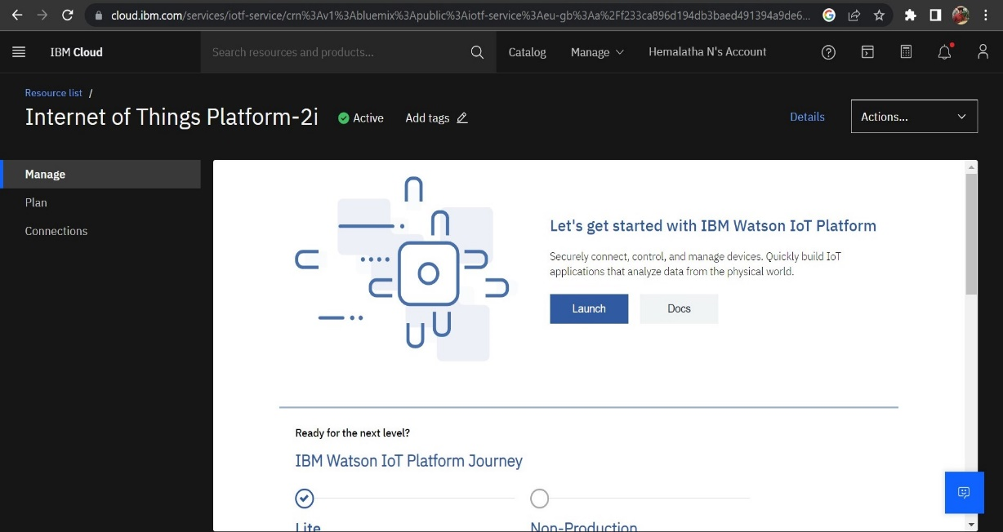

IBM IOT WATSON PLATFORM

